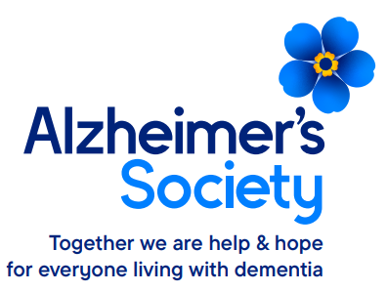
Subject Access Request Form
The purpose of this form is to ensure that all necessary information to complete your Subject Access Request is provided to the Society. Forms and information disclosed will be kept for two years after the request has been completed.

Whose information are you requesting?

☐ Your Own (complete section 1, 2, 5, 6a & 7) ☐Someone Else’s (complete section 1, 3, 4, 5, 6b & 7)

SECTION 1 Details of the Data Subject (the person the information is about)
Title: Select
Full Forename(s): |  | Surname:
Previous Name(s): |  | Date of Birth:
Relationship with Alzheimer’s Society
☐ Service User ☐ Supporter ☐ Volunteer
☐ Employee ☐ Other (Please specify)
Current Address:  Postcode: |  |  | Previous Address (if you lived at another address whilst in contact with the Society):  Postcode:
Telephone Number: |  |  | Email Address:

SECTION 2 Proof of Requester’s Identity
Data Protection legislation requires the Society to satisfy itself as to the identity of the person making the request. Please enclose a photocopy of one form of identification (for example, Passport, Driving Licence, Birth Certificate, etc.) and a copy of a document proving address in the last six months (for example, utility bill, council tax statement, bank statement/building society passbook, etc.). If the supply of this documentation is problematic, please contact us to discuss alternatives.

SECTION 3 Details of the person acting on behalf of the data subject
Full Name: |  | Relationship with the Data Subject:
Current Address (If different to the Data Subject)

Postcode:
Telephone Number: | Email Address:

SECTION 4 Proof of Authority to request the individual’s information
Please tick and enclose a copy of relevant authority

☐ Lasting Power of Attorney
☐ Written consent from the Data Subject

☐ Other (Please specify)

SECTION 5 Details of information requested
Description of the information requested (please be specific and continue on another sheet if necessary.):

SECTION 6 Declaration
PART A - Individual

The information which I have supplied in this application is correct, and I am the person to whom it relates.

Signature (Data Subject): _________________________________________ Date: Select date

PART B - Individual’s Representative

I am the individual’s representative and I believe I have the authority to request the above information from you.

Signature (Representative): ________________________________________ Date: Select date

SECTION 7 Submitting the Request Form

The completed Subject Access Request Form and the supporting copies of the documents proving identity and entitlement (if relevant) should be sent to:

Information Governance Team
Alzheimer’s Society,
Suite 2
1st Floor East Wing
Plumer House
Tailyour Road
Plymouth
PL6 5DH

Or by email to: information.governance@alzheimers.org.uk

Please note that any information you send to us is at your own risk, therefore, we suggest that you send the information securely.

Thank you for submitting your form and the relevant documents. You will receive an email or acknowledgement letter confirming receipt and the deadline by which we will respond. We will contact you if further information is required.

